Lecture No.41 PARASITOLOGY DR. Raad H.H.
"Mites "
ORDER: Mesostigmata (= Acariformes)
- about 250 described species are parasitic on vertebrates
- spiracles located just posterior and lateral to the third coxae
- usually a tube (tracheal trunk) extends anteriorly from each spiracle and can be seen through the cuticle. This is termed the peritreme
- bristle-like organ, the tritosternum, usually present immediately ventral and behind the gnathostoma
- generally, heavily scleratized bodies
- typical genera and species
  - Varroa jacobsoni (honey bee mite) commonly found on European honey bees (Apis mellifera); the mite is actually a species complex and not just one species
  - Dermanyssus gallinae (Red fowl mite) commonly found on chickens and pigeons; cosmopolitan
  - Ornithonyssus bacoti (tropical rat mite) often found infesting mice in laboratory rodent colonies; cosmopolitan
  - Ornithonyssus bursa (Tropical fowl mite)
  - Sternostoma tracheacolum (canary lung mite) in respiratory tract of canaries; cosmopolitan
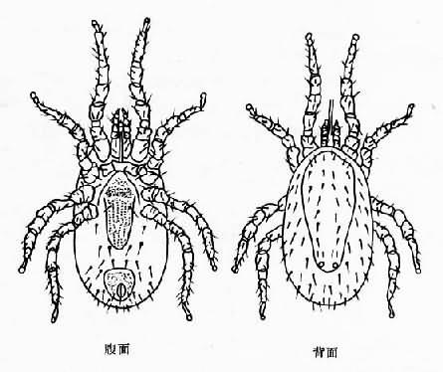

Dermanyssus gallinae

ORDER: Prostigmata
- spiracles either between chelicerae or dorsal on the mid-portion of the body
- generally poorly armored
- some species parasitic as adults; others only as larvae
- typical genera and species
  - Demodex canis (dog follicular mite) "Demodecidae" , may cause red mange in canids when secondary Staphlococcus pyogenes invade lesions; many other species of the genus in various animals; all cosmopolitan. i.e. Demodex injai on dogs; Demodex folliculorum and Demodex brevis in humans; Demodex cati and Demodex gatoi on cats; Demodex equi on horses; Demodex phylloides on pigs
  - Psorergates ovis (sheep itch mite) can cause dermal problems in sheep
  - Pyemotes tritici (straw itch mite) on grain beetles may attack mammals
  - Eutrombicula alfreddugusi (North American chigger) "Trombiculidae "and some other genera have larval stages that feed on blood. Nymphs and adults free-living. Often brightly colored. Some species may transmit scrub typhus, a rickettsia.
  - Hannemania penetrans (Anuran trombiculid mite) with larval stages encysting in reddish or orangish "mite pockets" in skin of frogs in North America
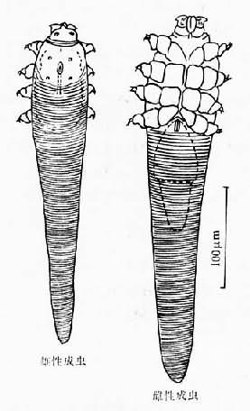

Demodex canis

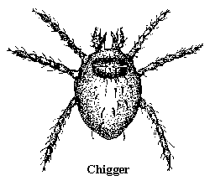

ORDER: Oribatida (oribatid mites)
- stigmata and tracheae usually present, opening into a porose area
- mouthparts drawn into a tube, the camerostome, which may have a hood-like sclerite covering it
- none parasitic

ORDER: Astigmata (itch mites)
- no tracheal systems; tegumental respiration
- claws absent; sucker-like structures on pretarsi
- many species and genera
  - Chorioptes bovis (mange in a variety of mammals; pierce skin but are non-invasive)
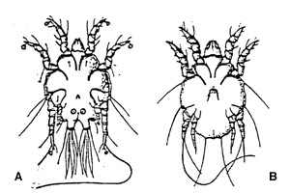

  - Dermatophagoides spp. (dust mites that can result in allergies)
  - Cnemidocoptes laevis (depluming mite of chickens, pheasants, and ducks) "Cnemidocoptidae"
  - Cnemidocoptes mutans (scaley-leg mite of chickens) " Cnemidocoptidae "
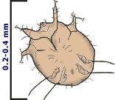
  - Notoedres cati (ear and facial mange in rodents, cats, and dogs; invasive where females burrow into the dermis)

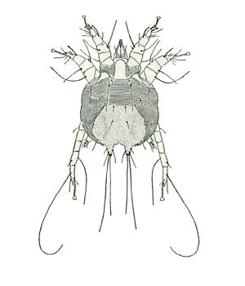
  - Psoroptes ovis ; many subspecies (mange in a variety of mammals; pierce skin but are non-invasive)

  - Otodectes cynotis (mange in felids, canids, mustelids; pierce skin but are non-invasive)
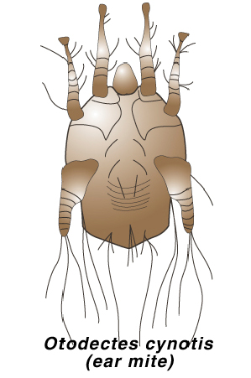

  - Sarcoptes scabiei (many subspecies where females invade and tunnel through dermis causing intense dermatitis)
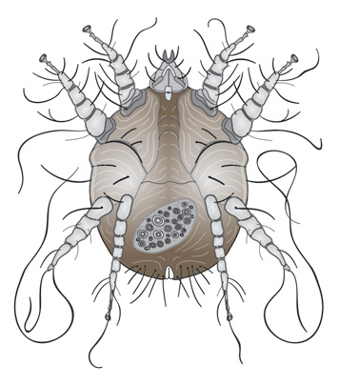

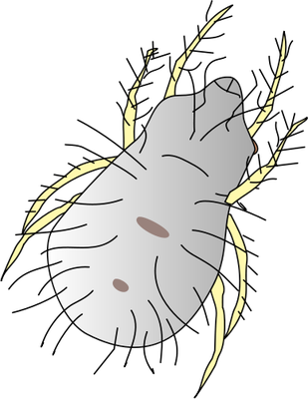
  - Dermatophagoides pteronyssinus (European house-dust mite) and Dermatophagoides farinae (American house-dust mite) both have worldwide distributions. Live in bed clothes, mattresses, carpets, and house dust and may cause allergies

- Family Sarcoptidae ( burrowing mites )
Genera :
Sarcoptes
Characters :
spherical shape ; scutum wrinkled ; legs two groups , frontal 2 pairs long and posterior 2 pairs short not extends body mite.
Other genera Notoedres, Trixicarus
- Family Psoroptidae (Non burrowing mites )
Genera :
Psoroptes
Characters: oval shape ; scutum not wrinkles ; legs long and extends body mite.
Other genera Chorioptes ,Otodectes

